Pedigrees

Key terms
Term | Meaning
Pedigree | Chart that shows the presence or absence of a trait within a family across generations
Genotype | The genetic makeup of an organism (ex: TT)
Phenotype | The physical characteristics of an organism (ex: tall)
Dominant allele | Allele that is phenotypically expressed over another allele
Recessive allele | Allele that is only expressed in absence of a dominant allele
Autosomal trait | Trait that is located on an autosome (non-sex chromosome)
Sex-linked trait | Trait that is located on one of the two sex chromosomes
Homozygous | Having two identical alleles for a particular gene
Heterozygous | Having two different alleles for a particular gene
Pedigrees are used to analyze the pattern of inheritance of a particular trait throughout a family. Pedigrees show the presence or absence of a trait as it relates to the relationship among parents, offspring, and siblings.

Reading a pedigree
Pedigrees represent family members and relationships using standardized symbols.
By analyzing a pedigree, we can determine genotypes, identify phenotypes, and predict how a trait will be passed on in the future. The information from a pedigree makes it possible to determine how certain alleles are inherited: whether they are dominant, recessive, autosomal, or sex-linked.
To start reading a pedigree:
- Determine whether the trait is dominant or recessive. If the trait is dominant, one of the parents must have the trait. Dominant traits will not skip a generation. If the trait is recessive, neither parent is required to have the trait since they can be heterozygous.
- Determine if the chart shows an autosomal or sex-linked (usually X-linked) trait. For example, in X-linked recessive traits, males are much more commonly affected than females. In autosomal traits, both males and females are equally likely to be affected (usually in equal proportions).

Example: Autosomal dominant trait
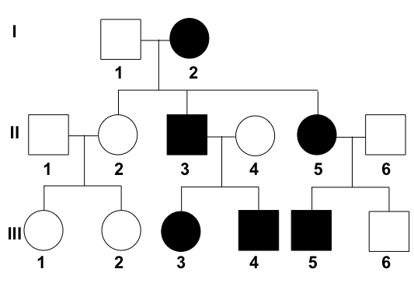
This pedigree is showing the inheritance of freckles across three generations.
The diagram shows the inheritance of freckles in a family. The allele for freckles (F) is dominant to the allele for no freckles (f).
At the top of the pedigree is a grandmother (individual I-2) who has freckles. Two of her three children have the trait (individuals II-3 and II-5) and three of her grandchildren have the trait (individuals III-3, III-4, and III-5).
What is the genotype of individual I-2?]

Example: X-linked recessive trait
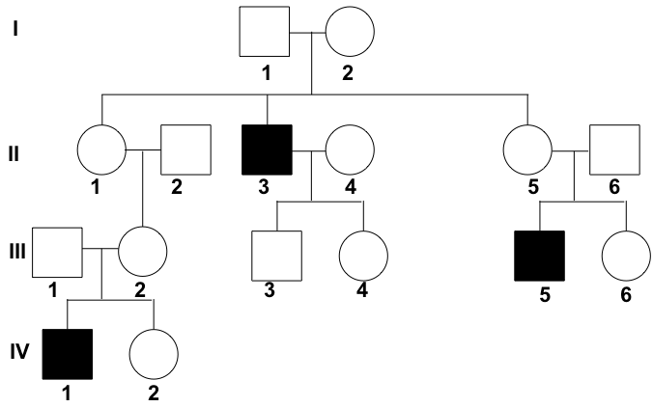
Pedigree showing the inheritance of colorblindness across four generations.
The diagram shows the inheritance of colorblindness in a family.
Colorblindness is a recessive and X-linked trait (X_{b}).
The allele for normal vision is dominant and is represented by X_{B}.
In generation I, neither parent has the trait, but one of their children (II-3) is colorblind. Because there are unaffected parents that have affected offspring, it can be assumed that the trait is recessive. In addition, the trait appears to affect males more than females (in this case, exclusively males are affected), suggesting that the trait may be X-linked.

